**SALES AND REVENUE OVERVIEW-**

**Cards – Total revenue**

**Total orders**

**Total customers**

**Slicer - Year**

**TOP CATEGORIES BY TOTAL PRICE-**

**Identify and visually represent the top 10 product categories by total sales**

For this task check sales and revenue overview. For this task created a bar chart using Y axis as product category name and X axis as total price. Column created as total price using quantity and price and visualization shown in dashboard representing 10 topmost product categories.

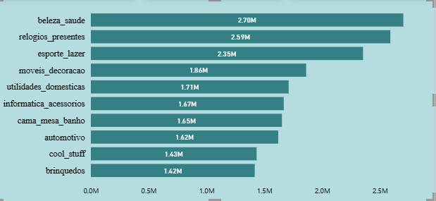

**REVENUE ANALYSIS**

**Determine the total revenue generated by shopnest store and analyze how it changes over time yearly represent this info through suitable visualization to highlight trends and patterns**

For this task check sales and revenue overview. For this task created a line chart using X axis as Year from shipping limit date and Y axis as total price.

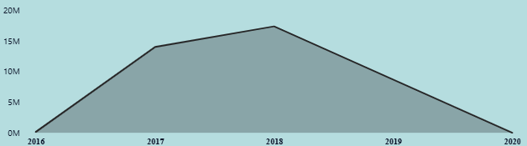

**SEASONAL SALES PATTERN**

**Investigate and visualize any seasonal patterns quarterly or trends in sales data over the course of the year**

For this task check sales and revenue overview. For this task created a column chart using X axis as quarters from shipping limit date and Y axis as total price.

For checking year wise quarters use slicer and check year for which data required.

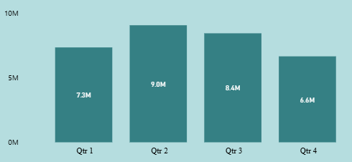 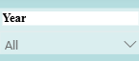

**STATE-WISE SALES ANALYSIS**

**Identify and visually represent states with high and low sales, providing a clear understanding of regional sales performance**

For this task check sales and revenue overview. For this task created a pie chart using seller state and total price. Legend showing state names.

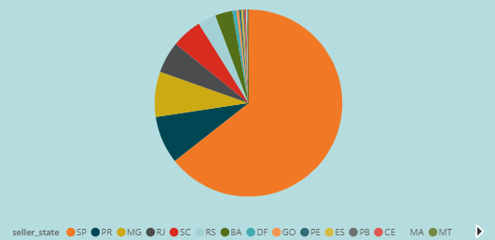

**CUSTOMER FEEDBACK INSIGHTS-**

**Cards - Total orders**

**Avg Ratings**

**Slicer – Product category names**

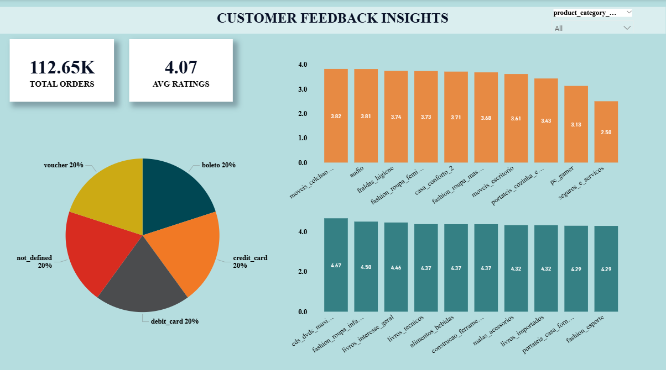

**PRODUCT RATING ANALYSIS**

**Determine the top 10 highest-rated products and the bottom 10 lowest-rated products using a bar or column chart**

For this task check customer feedback insights. For this task created a column chart using X axis as product category name and Y axis as avg rating score. For top 10 represented in green color while bottom 10 represented in red color.

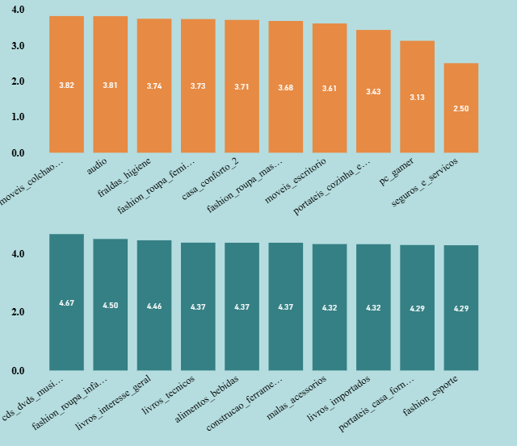

**PAYMENT METHOD ANALYSIS**

**Analyze the most frequently used payment methods by customers using a visually appealing representation, such as a pie chart or other suitable visuals**

For this task check sales and revenue overview. For this task created a pie chart using payment type and count of customer id.

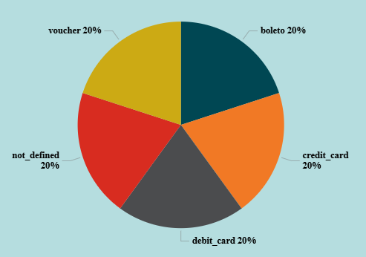

**ORDERS AND DELIVERY PERFORMANCE-**

**Cards - Total orders**

**Count of delayed orders**

**Slicer – year and month**

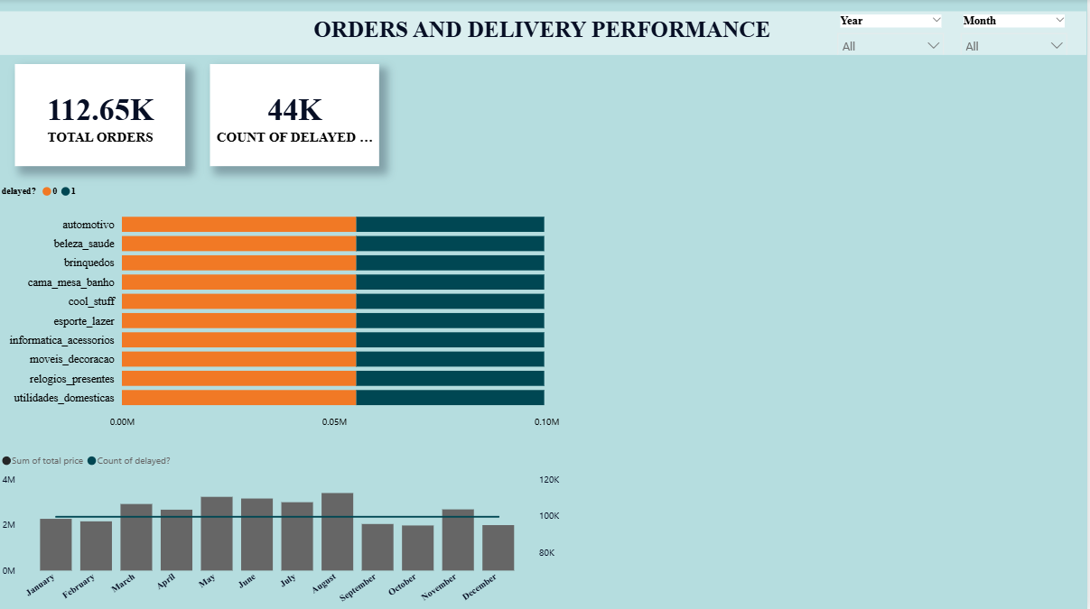

**DELAYED ORDERS ANALYSIS**

**Determine the number of delayed orders in each category. An order is considered delayed if the actual delivery date is later than the estimated delivery date**

For this task check orders and delivery performance. For this task created a bar chart using X axis as count of delayed and Y axis as product category name. For delayed created column using measure with the help of if condition. For delay represented in green color while not delayed represented in red color.

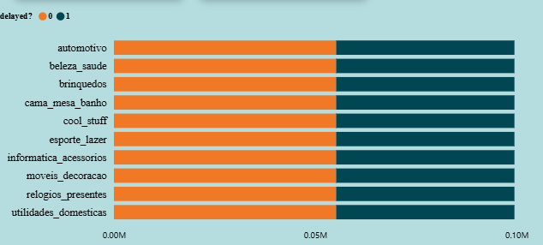

**MONTHLY COMPARISON OF DELAYED AND ON-TIME ORDERS**

**Create a dynamic visual that compares the number of delayed orders to the number of orders received earlier for each month. Utilize the drill through cross-report feature to provide a detailed analysis of late and on-time deliveries.**

For this task check orders and delivery performance. For this task created a line and column chart using X axis as month from shipping date and Y axis as total price and secondary Y axis for line chart as count of delayed.

